MongoDB is required to be installed on the Home Monitor system to store predominately sensor and event information. The Home Monitor will be running Windows 10.

MongoDB will also be installed on the Supervisor system, which will be a linux distribution. The distro is TBC. The database on the supervisor will store alarm, report, and operator information.

**MongoDB Home Monitor Setup Guide**

**Install**

1. Download the x86 msi installer of MongoDB Community Server from <https://www.mongodb.com/download-center?ct=atlasheader#community>
2. Open the installer. Select Next.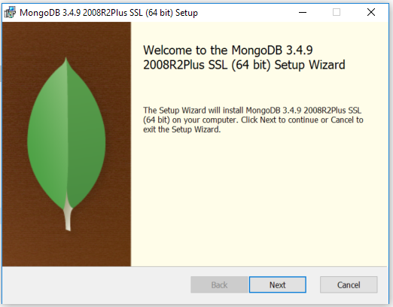
3. Accept the Terms. Select Next.

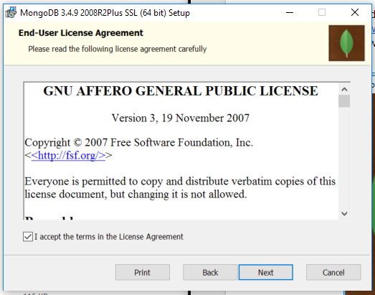

1. Select Complete, then Install. Accept the UAC prompt.

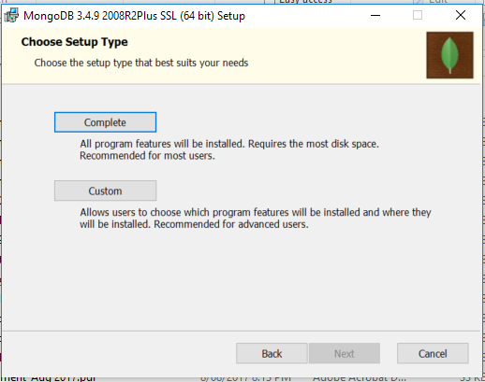

1. Select Finish.

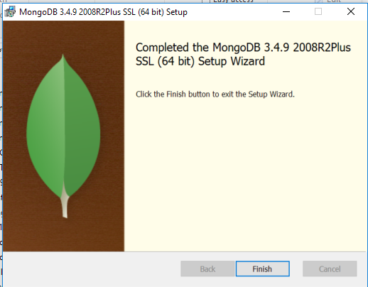

**Setup environment**

1. Run cmd as administrator and execute the following commands to create a directory for the database files and log files respectively

mkdir c:\data\db  
 mkdir c:\data\log

1. Run notepad as administrator.
2. Paste the following text into the untitled notepad file.

systemLog:  
 destination: file  
 path: c:\data\log\mongod.log  
storage:  
 dbPath: c:\data\db

1. Save the file as mongod.cfg in the C:\Program Files\MongoDB\Server\3.4\ directory.

**Start MongoDB as a WIndows Service**

This will cause MongoDB to start automatically on startup.

1. Run cmd as administrator and execute the following command

sc.exe create MongoDB binPath= "\"C:\Program Files\MongoDB\Server\3.4\bin\mongod.exe\" --service --config=\"C:\data\mongod.cfg\"" DisplayName= "MongoDB" start= "auto"

**Connect to MongoDB**

1. Open cmd and run the following command

"C:\Program Files\MongoDB\Server\3.4\bin\mongo.exe”